Cucumber_Java_Install

Installed before (IntelliJ IDEA; Java; TestNG; Appium; Apache POI; MySQL-connector):

<**dependency**>  
 <**groupId**>org.testng</**groupId**>  
 <**artifactId**>testng</**artifactId**>  
 <**version**>6.10</**version**>  
 <**scope**>test</**scope**>  
</**dependency**>  
<**dependency**>  
 <**groupId**>io.appium</**groupId**>  
 <**artifactId**>java-client</**artifactId**>  
 <**version**>7.1.0</**version**>  
</**dependency**>  
<**dependency**>  
 <**groupId**>org.apache.poi</**groupId**>  
 <**artifactId**>poi-ooxml</**artifactId**>  
 <**version**>4.0.1</**version**>  
</**dependency**>  
<**dependency**>  
 <**groupId**>mysql</**groupId**>  
 <**artifactId**>mysql-connector-java</**artifactId**>  
 <**version**>8.0.17</**version**>  
 <**exclusions**>  
 <**exclusion**>  
 <**groupId**>com.google.protobuf</**groupId**>  
 <**artifactId**>protobuf-java</**artifactId**>  
 </**exclusion**>  
 </**exclusions**>  
</**dependency**>

Install Cucumber & Gherkin Plugins

Open IntelliJ. **Go to: File -> Settings** and click on **Plugins.** Select Marketplace and search for **Cucumber**.

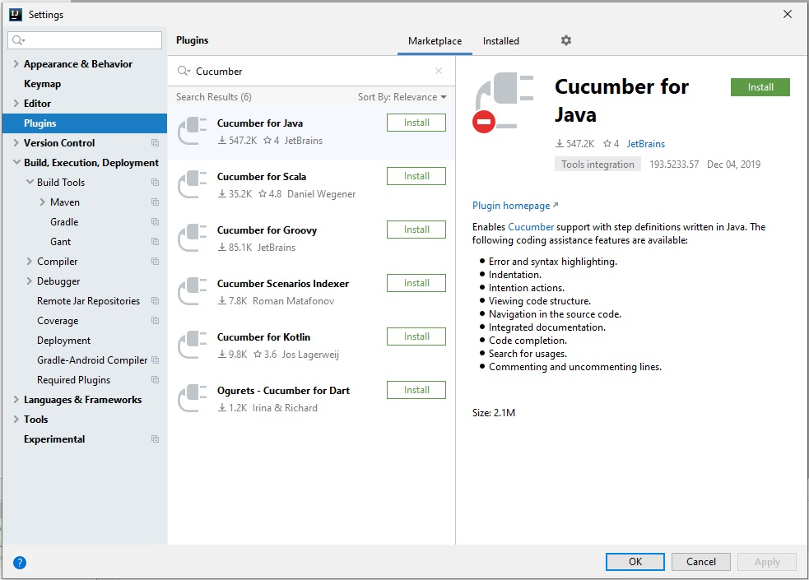

Install **Cucumber for Java** and restart IntelliJ.

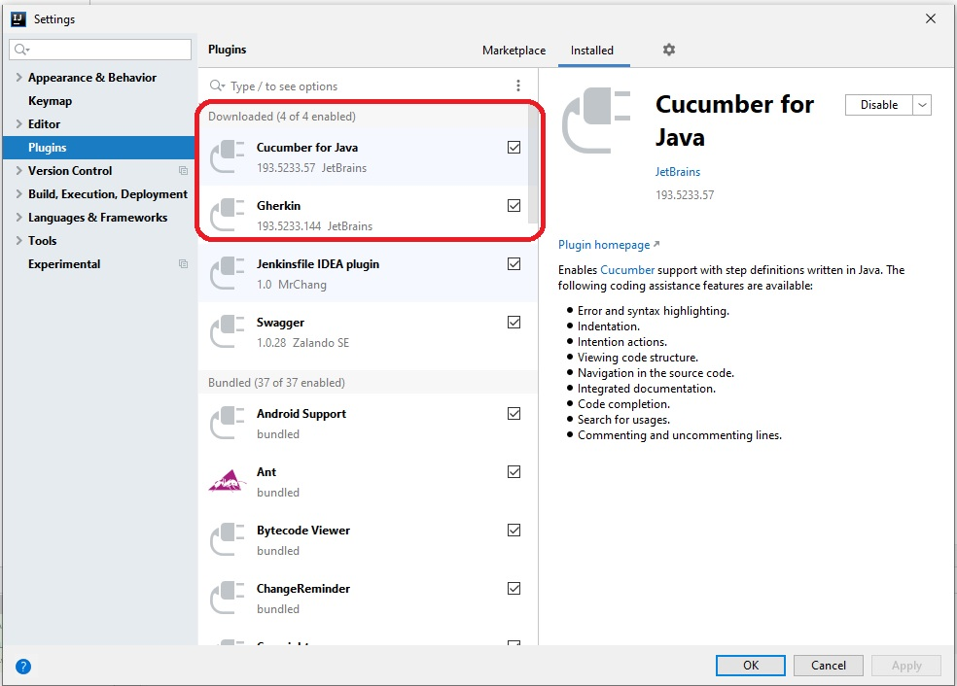

Open the POM.xml file and add dependencies for cucumber:

<https://mvnrepository.com/artifact/io.cucumber/cucumber-java8/4.8.0>

<dependency>

<groupId>io.cucumber</groupId>

<artifactId>cucumber-java8</artifactId>

<version>4.8.0</version>

</dependency>

<https://mvnrepository.com/artifact/io.cucumber/cucumber-testng>

<dependency>

<groupId>io.cucumber</groupId>

<artifactId>cucumber-testng</artifactId>

<version>4.8.0</version>

</dependency>

On the right-hand side of the IntelliJ IDE, click **Maven Projects**tab to show Maven lifecycle. Click **re-import Maven Projects** button to update from the POM.

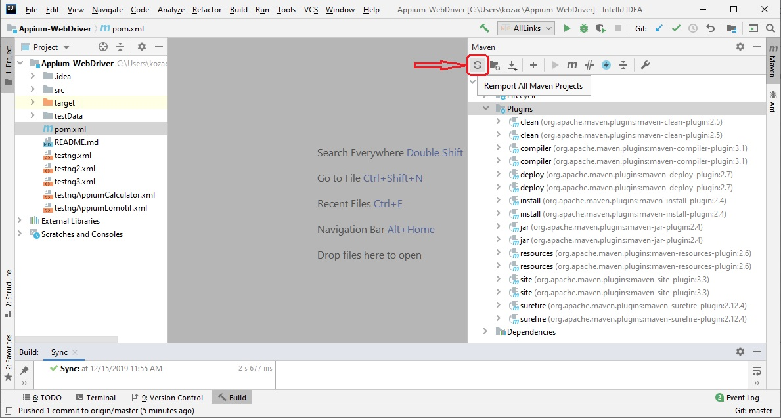

Right-click on the **java** folder under **test**, and add 2 new packages: **"bindings" & "runners".**

**Also, we have directory "**resources**"** under the "test" folder.

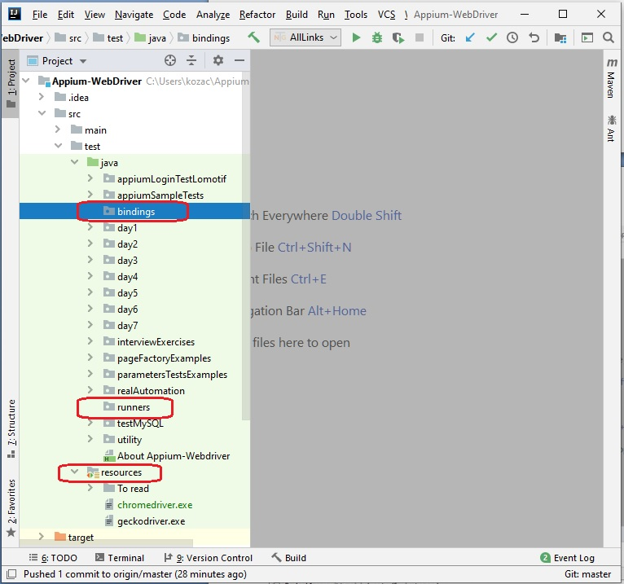

Feature File

Create new directoryshugaringFactory **in the folder** resources**.**

Create new filebasket.feature **in the folder** shugaringFactory**.**

Write your feature, example:

@run  
**Feature**: basket  
 *#shopping basket features* **Scenario**: add to basket  
 **Given** that i am on the shopping website  
 **When** i add an item to the basket  
 **Then** i can view the item in my basket

**Run** basket.feature file. This Feature file has no code bindings.

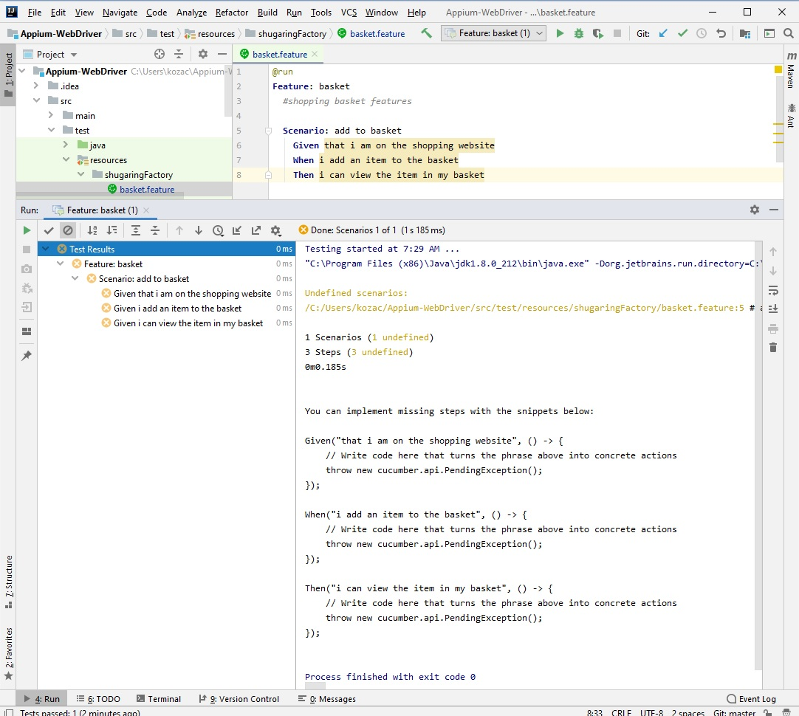

It will suggest some pattern code bindings for you, in the Run pane.

Select these and copy to the clipboard.

Given("that i am on the shopping website", () -> {

// Write code here that turns the phrase above into concrete actions

throw new cucumber.api.PendingException();

});

When("i add an item to the basket", () -> {

// Write code here that turns the phrase above into concrete actions

throw new cucumber.api.PendingException();

});

Then("i can view the item in my basket", () -> {

// Write code here that turns the phrase above into concrete actions

throw new cucumber.api.PendingException();

});

Create new Java Class Basket.java in the package bindings.

Paste in your pattern code.

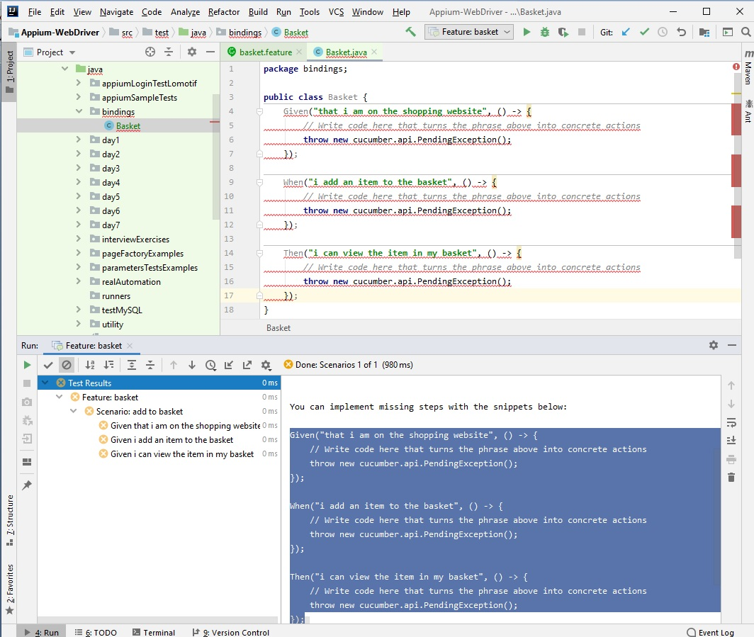

Put @ - annotations to Given; When; Then. Click in a line of code error and use Alt-Enter to fix imports.

**package** bindings;  
**import** io.cucumber.java.en.Given;  
**import** io.cucumber.java.en.Then;  
**import** io.cucumber.java.en.When;  
**import** org.openqa.selenium.*;  
**import** org.openqa.selenium.chrome.ChromeDriver;  
**import** org.openqa.selenium.interactions.Action;  
**import** org.openqa.selenium.interactions.Actions;  
**import** org.openqa.selenium.support.ui.ExpectedConditions;  
**import** org.openqa.selenium.support.ui.WebDriverWait;  
**import** java.util.concurrent.TimeUnit;  
  
**import static** org.testng.Assert.*assertEquals*;  
**import static** org.testng.Assert.*assertTrue*;  
**public class** Basket {  
 WebDriver **driver**;  
 String **quantity** = **"20"**;  
 String **actualQuantity**;  
  
 @Given(**"^that i am on the shopping website$"**)  
 **public void** that_i_am_on_the_shopping_website() **throws** Throwable {  
 System.*setProperty*(**"webdriver.chrome.driver"**, System.*getProperty*(**"user.dir"**) +  
 **"\\src\\test\\resources\\chromedriver.exe"**);  
 **driver** = **new** ChromeDriver();  
 **driver**.manage().timeouts().implicitlyWait(15, TimeUnit.***SECONDS***);  
 **driver**.get(**"https://test.sugaringfactory.com/"**);  
 **driver**.manage().window().maximize();  
 }  
 @When(**"^i add an item to the basket$"**)  
 **public void** i_add_an_item_to_the_basket() **throws** Throwable {  
 **driver**.findElement(By.*xpath*(**"//div[contains(text(),'Soft')]"**)).click();  
 **driver**.findElement(By.*xpath*(**"//input[@name='quantity']"**)).clear();  
 **driver**.findElement(By.*xpath*(**"//input[@name='quantity']"**)).sendKeys(**quantity**);  
 **driver**.findElement(By.*xpath*(**"//input[@id='button-cart']"**)).click();  
 **driver**.manage().timeouts().implicitlyWait(15, TimeUnit.***SECONDS***);  
 Thread.*sleep*(3000);  
 **driver**.findElement(By.*xpath*(**"//div[@class='success']//i[@class='icon-remove-sign']"**)).click();  
 **driver**.manage().timeouts().implicitlyWait(15, TimeUnit.***SECONDS***);  
 }  
 @Then(**"^i can view the item in my basket$"**)  
 **public void** i_can_view_the_item_in_my_basket() **throws** Throwable {  
 Actions builder = **new** Actions(**driver**);  
 Action mouseOverHome = builder  
 .moveToElement(**driver**.findElement(By.*xpath*(**"//div[@id='cart']"**)))  
 .build();  
 **for**(**int** r=0; r<10; r++) {  
 **try** {  
 **driver**.manage().timeouts().implicitlyWait(15, TimeUnit.***SECONDS***);  
 mouseOverHome.perform();  
 **driver**.manage().timeouts().implicitlyWait(15, TimeUnit.***SECONDS***);  
 Thread.*sleep*(3000);  
 **actualQuantity** = **driver**.findElement(By.*xpath*(**"//span[@class='quantity']"**)).getText();  
 System.***out***.println(**"Added to cart: "** + **actualQuantity**);  
 *assertEquals*(**actualQuantity**,**"X "** + **quantity**);  
 **break**;  
 } **catch**(StaleElementReferenceException e) {  
 e.toString();  
 System.***out***.println(**"Trying to recover from a stale element :"** + e.getMessage());  
 }  
 }  
 Thread.*sleep*(3000);  
 **driver**.quit();  
 }  
}

Update chromedriver, if it is necessary: <https://sites.google.com/a/chromium.org/chromedriver/downloads>

Before we can execute feature files, we need to tell IntelliJ where the feature files & code are bindings.

Open basket.feature file. In IntelliJ menu, Run->Edit Configurations.

Click on the feature name on the left (Feature: basket) and − provide the **Glue** (package that the code bindings will reside) (bindings) and − the **Feature or Folder Path** (where are Features files reside) (C:/Users/kozac/Appium-WebDriver/src/test/resources/shugaringFactory/basket.feature).

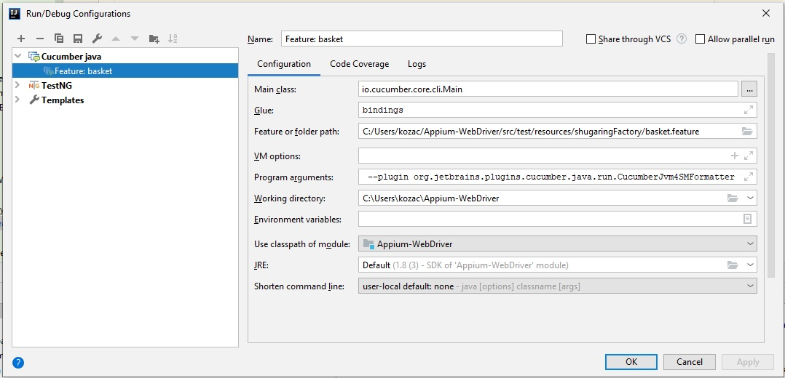

OK. Now we can execute the Feature file. It should open a Web Browser and perform the test.

